Bug Reporting Document
Project Name: EMI Calculator Application
Module: Home Loan
Reported By: Suraj Nepali
Environment: Test
Date: 26-Feb-2026
Browser: Chrome 145.0
OS: Linux (Ubuntu)

BugID: BUG-001

TestCaseID: TC_HomeLoan_025
Title
Application gets stuck at "Calculating EMI" when extremely large values are entered for Loan Tenure.

Description
When extremely large numerical values, such as 101010, are entered for both Interest Rate and Tenure, the application doesn't display any results but gets stuck at the loading state showing "Calculating EMI" for an indefinite period of time.

Application gets stuck at "Calculating EMI," showing no response or validation error, nor displaying the calculated EMI.

Module
Home Loan

Environment
Environment: Test
Browser: Chrome 145.0
OS: Linux Ubuntu

Steps to reproduce
- Navigate to EMI Calculator.
- Select Home loan tab
- Enter Loan Amount: 5000000
- Enter Interest Rate: 9
- Enter Tenure: 202020
- Click outside the field.

Expected Result
- The system should be able to validate input ranges.
- Either:
  - Display validation error message (e.g., "Interest rate exceeds allowed limit")
  - Or: Restrict input to the maximum allowed input
  - Or: Handle the calculation and display of the result nicely
- Loaders should not be stuck indefinitely.

Actual Result
- Loader is displayed with "Calculating EMI"
- No results are displayed
- No validation message is displayed
- The application is frozen

Severity
High
Reason:
- Freezing of the application
- Poor User Experience
- No handling of validation
- Potential Performance Issue
- Can cause browser crash for users

Priority
High
Must be fixed before production release.

Evidence
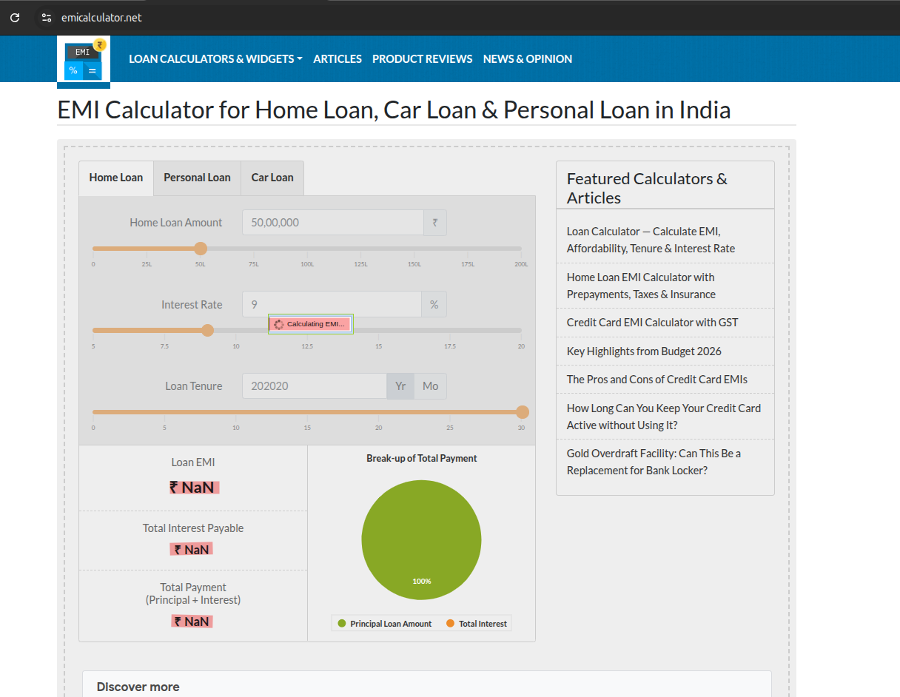

BugID: BUG-002

TestCaseID: TC_HomeLoan_025
Title
Auto conversion of hyphenated numbers (20-9283) to numbers (209283) in the ‘Interest Rate’ or ‘Tenure’ field

Description
If the user is trying to input a hyphenated number such as 20-9283 in the ‘Interest Rate’ or ‘Tenure’ field, the system auto-converts the input to the number 209283 without showing any validation error.

Module
Home Loan

Environment
Environment: Test
Browser: Chrome 145.0
OS: Linux Ubuntu

Steps to reproduce
- Navigate to EMI Calculator.
- Select Home loan tab
- In the field "Interest Rate," enter the text: 20-9283
- Click outside the field
- Observe the value auto-updated to 209283.
(The same is true for the "Tenure" field.)

Expected Result
The system should:
- Not accept the invalid numeric format.
- Show the error message:
"Invalid input format. Only numeric values are allowed."
- OR: Do not allow the input of special characters.
- Should not auto-update the input value.

Actual Result
- System removes the hyphen (-)
- 20-9283 is converted to 209283
- No validation message is displayed
- User is unaware that input has been modified
- Calculation for EMI continues with wrong input

Severity
Medium to High
Reason:
- No crash is encountered
- But it leads to a wrong financial calculation
- Silent data manipulation
- Poor UX and trust issue

Priority
High
Should be fixed before production to avoid incorrect EMI computation.

Evidence
